**Data Flow Diagrams:**

Project Design Phase-II

Data Flow Diagram & User Stories

|  |  |
| --- | --- |
| Date | 16 October 2022 |
| Team ID | IBM-Project-31710-1660204454 |
| Project Name | IoT Based Safety Gadget for Child Safety  Monitoring & Notification |
| Maximum Marks | 4 Marks |

A Data Flow Diagram (DFD) is a traditional visual representation of the information flows within a system. A neat and clear DFD can depict the right amount of the system requirement graphically. It shows how data enters and leaves the system, what changes the information, and where data is stored.

**DATA FLOW DIAGRAM:**

**IoT Based Safety Gadget for Child Safety Monitoring & Notification**

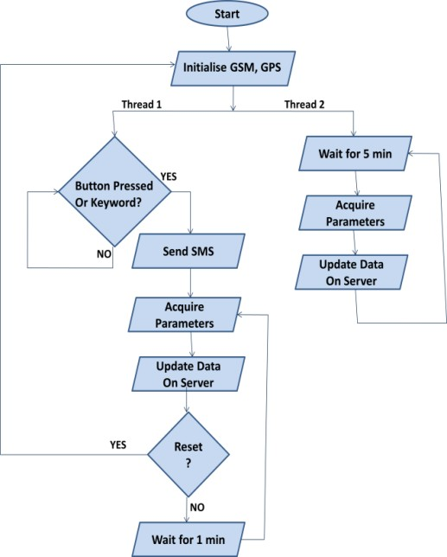

**User Stories**

Use the below template to list all the user stories for the product.

|  |  |  |  |  |  |  |
| --- | --- | --- | --- | --- | --- | --- |
| **User Type** | **Functional Requirement (Epic)** | **User Story Number** | **User Story / Task** | **Acceptance criteria** | **Priority** | **Release** |
| Customer (Mobile user) | Registration | USN-1 (FATHER) | As a user, I can register by entering my email, password, and confirming my password. I can access the location of my children using the  credentials provided as a Father. | I can access my account / dashboard and receive confirmation email & click  confirm | High | Sprint-1 |
|  |  | USN-2 (MOTHER) | As a user, I can register by entering my email, password, and confirming my password. I can access the location of my children using the credentials provided as a Mother. | I can access my account / dashboard and receive confirmation email & click confirm | High | Sprint-1 |
|  |  | USN-3 (GUARDIAN/ CARETAKER) | As a user, I can also monitor the children’s activities using a safety gadget monitoring system. | I can access my account / dashboard and receive  confirmation email & click confirm | Medium | Sprint-1 |
|  | Login | USN-4 | As a user, I can log into the application by entering  email & password. | I can access my account /  dashboard. | Medium | Sprint-2 |
|  | Dashboard | USN-5 | As a user, I can fix the geofence for my child’s location so that I will receive alerts if my child crosses the geofence. | I can monitor the current location of my child. | High | Sprint-2 |
| Customer (Web user) | Registration | USN-1 (FATHER) | As a user, I can register by entering my email, password, and confirming my password. I can access the location of my children using the  credentials provided as a Father. | I can access my account / dashboard and receive confirmation email & click  confirm | High | Sprint-1 |
|  |  | USN-2 (MOTHER) | As a user, I can register by entering my email, password, and confirming my password. I can access the location of my children using the  credentials provided as a Mother. | I can access my account / dashboard and receive confirmation email & click  confirm | High | Sprint-1 |
|  |  | USN-3 (GUARDIAN/ CARETAKER) | As a user, I can also monitor the children’s activities using a safety gadget monitoring system. | I can access my account / dashboard and receive confirmation email & click confirm | Medium | Sprint-1 |

|  |  |  |  |  |  |  |
| --- | --- | --- | --- | --- | --- | --- |
| **User Type** | **Functional Requirement (Epic)** | **User Story Number** | **User Story / Task** | **Acceptance criteria** | **Priority** | **Release** |
|  | Login | USN-4 | As a user, I can log into the application by entering email & password. | I can access my account / dashboard. | Medium | Sprint-2 |
|  | Dashboard | USN-5 | As a user, I can fix the geofence for my child’s location so that I will receive alerts if my child  crosses the geofence. | I can monitor the current location of my child. | High | Sprint-2 |
| Customer Care | Dashboard | USN-6 | As a customer care service person, whenever I receive a complaint, I forward the complaint and ensure that the complaint is resolved. | I can keep track of all the complaints and the status of the complaints received. | Medium | Sprint-3 |
| Administrator | Admin Dashboard | USN-7 | As an administrator, I will take care of all the payment processes, queries and complaints and  login credentials. | I can access all the customer details, payment details and  complaints received. | High | Sprint-4 |